12.48: a) The direction from the origin to the point midway between the two large masses is arctan found in the example.

b) The common lever arm is 0.100 m, and the force on the upper mass is at an angle of

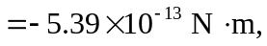

with the minus sign indicating a clockwise torque. c) There can be no net torque due to gravitational fields with respect to the center of gravity, and so the center of gravity in this case is not at the center of mass.

